TEMPLATE INSTRUCTIONS
This template document contains guidance notes, such as this one. These instructions should therefore be deleted before the release of the document. This also applies to this chapter "Template instructions". Information highlighted in yellow should also be evaluated and completed.
Sections that are indicated as optional can be deleted. Also, required content can be added.
The version history below applies to the template and not to the resulting document. Clean up the table as needed and use it for your document control purposes.
Template Version History
Version | Date of validity | Author | Description of change
1 | 2022-04-04 | Célia Cruz | First version
2 | 2022-06-29 | Célia Cruz | Review formatting

Version History
Version | Date of validity | Created by | Approved by | Description of change
1 | YYYY-MM-DD | [Name, including digital signature] | [Name, including digital signature] | First version

Purpose
This document describes the architecture of the software for the technical implementation of the software requirements.

Responsibilities
Please adapt the responsibilities accordingly to your company.
This document was created by the CTO / Head of Software Development / Software Development Project Manager. It is their responsibility and of software developers to further develop and complete this document.

Context

Product / Software
Name of the product | Version of the product | Software version of the product | Basic UDI-DI (optional)
< name of the product> | <version of the product. If standalone software, use either this or the next column and delete the other> | <version of the software> | <Basic UDI-DI, if/when available>

Architecture

Architecture overview
Provide a general description of the system, from the point of view of the user:
- What environment does it work (home, near-patient bed, operating room …),
- Who the users are,
- What it is for,
- The main functions,
- The main interfaces, inputs, and outputs.
If your software is integrated with a larger system, you may reference a document that describes this system.

Physical architecture overview
Not required if the software is not software safety class C according to IEC 62304.
Describe the hardware components on which software runs and their interactions/relationships. You can use components diagrams, deployment diagrams, network diagrams, and interface diagrams.
Describe each hardware component.

Logical architecture overview
Not required if the software is not software safety class C according to IEC 62304.
Describe the top-level software components and their interactions/relationships. Use UML package diagrams and/or layer diagrams and/or interface diagrams. Also describe the operating systems on which the software runs. The description should contain:
- Software component identification,
- Purpose of the component,
- Component interfaces with other components,
- Component network interfaces,
The hardware resources it uses. You can use indicators such as: average RAM usage, peak RAM usage and peak frequency and duration, disk space for permanent data, disk space for cache data, average CPU usage, peak CPU usage.

Software SOUP
If the software uses SOUP (Software Of Unknown Provenance), list them here.
For each SOUP, describe:
- Identification and version,
- Purpose,
- Manufacturer.
- Whether it is maintained by a third party or not,
- If it is an executable,
- What are the hardware / software resources it uses,
- Integration of the SOUP in the software,
- Segregation in the architecture,
- Interfaces and data flows,
- What hardware/software resources does it require for proper use.

Dynamic behavior of architecture
Optional. The architecture is designed to answer functional requirements. For each main function of the system, describe the exchange of messages between objects using a sequence diagram, for example.
The number of runtime scenarios should be based on the security-relevant usage scenarios.

Static view (Module view/Components)

Overview of top-level components
Add a component diagram, showing the top level of components. It should also identify the security class of each component, and displays SOUPs.
Update the following diagram for your own case. The one below is for illustration purposes only.
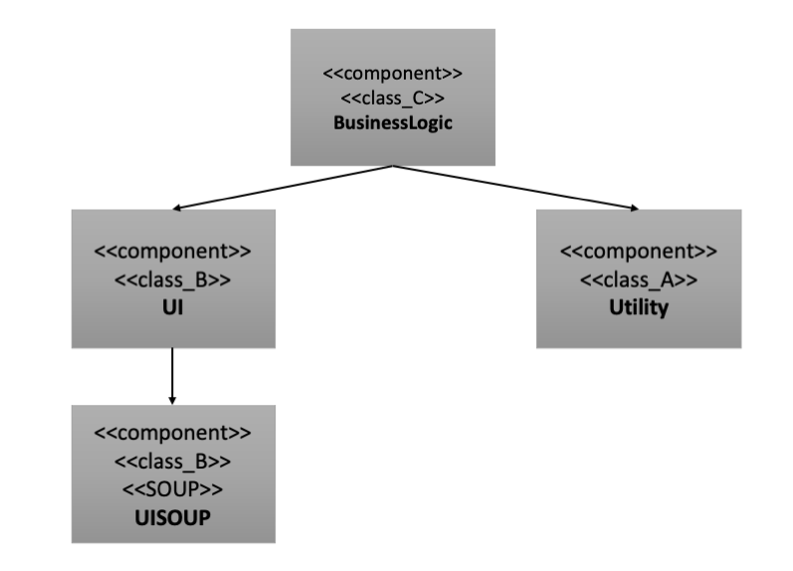

Overview of self-developed components
List the individual self-developed components according to the diagram from the previous section and provide the necessary information. The safety class of the components is determined by risk management. For each component, the same rationale as described in FRW-SW-09 Software Safety Classification should be used.

Component | Description | Safety classification
<Component name> | <Description of task> | <Safety classification>

Overview of used SOUP components
List the individual SOUP components used and complete the necessary information according to the following table.
The security class of the SOUP components is determined by the risk management or the SOUP component receives the security class of the user's self-developed component.

Description | Manufacturer | Version | Description | Safety classification
<SOUP-Name> | <Manufacturer, URL if applicable> | <SOUP-Version> | <Short-Description> | <Safety classification>

Description of components
The first level describes the components identified in the above component diagram from a black-box perspective. You can have a subchapter for each component.

Second level components (Detailed Design)
The second level describes the "inner life", i.e. the white-box view of the individual components from the first level. You can have a subchapter for each component. Only required for software safety classification C from IEC 62304.

Database scheme
Describe the database scheme. The division of the system into components should be reflected in the database or database schema.

Risks
If the results of risk analysis have an impact on the architecture, describe here for each risk analysis output what has been done to mitigate the risk in the architecture. Use diagrams, if necessary, like architecture before risk mitigation and architecture after risk mitigation, to explain the choices.
You can also refer to Risk Analysis.
All risks connected are identified in the TMP-RM-01 Risk Management File.

Traceability
Describe how system or software requirement specifications are addressed and connected to components and risks. Alternatively, you can ensure the relationship between software requirements and software architecture within a software architecture review. Add a table with traceability of components of this document with requirements from TMP-SW-04_Software_Requirements_Specifications that need to be implemented as functionalities. In case a high-level function is handled by many components, you can make it easier by quoting only the component(s) with the major role.

Requirement | Component | Comment
REQ-001  The device shall do xyz | COMPO-001: name component | COMP-001 does xyz.  COMP-002 also does verification of the result.

Annex

Applicable and relevant documents
Document Identification | Document Title
TMP-RM-01 | Risk Management File
TMP-SW-04 | Software Requirements Specification
SOP-SW-01 | Procedure Software Development
TMP-SW-02 | Software Development Plan

